**SIMATS SCHOOL OF ENGINEERING**

## SAVEETHA INSTITUTE OF MEDICAL AND TECHNICAL SCIENCES

**CHENNAI-602105**

A Simple Course Management system

**A CAPSTONE PROJECT REPORT**

*Submitted in the partial fulfilment for the award of the degree of*

# BACHELOR OF ENGINEERING

# IN

# COMPUTER SCIENCE

**Submitted by**

**Ch.Bhanu Prakash (Reg no:192211091)**

**K.Vasanth Kumar(Reg no.192211930)**

**Under the Supervision of**

**Ms. B. Jeevashri**

**July 2024**

# DECLARATION

We, **Ch. Bhanu Prakash, K. Vasanth Kumar** students of **Bachelor of Engineering in computer science**, Department of Computer Science and Engineering, Saveetha Institute of Medical and Technical Sciences, Saveetha University, Chennai, hereby declare that the work presented in this Capstone Project Work entitled **A Simple course Management system** is the outcome of our own bonafide work and is correct to the best of our knowledge and this work has been undertaken taking care of Engineering Ethics.

1. Ch.Bhanu Prakash(192211091)
2. K.Vasanth Kumar(192211930)

Date: 31-07-2024

Place: Chennai

# CERTIFICATE

This is to certify that the project entitled **“A simple Course Management system”** submitted by **Ch. Bhanu Prakash and Vasanth Kumar** has been carried out under my supervision. The project has been submitted as per the requirements in the current semester of B.E. Computer Science.

Teacher-in-charge

**Ms. B. Jeevashri**

**Table of Contents**

|  |  |
| --- | --- |
| **S.NO** | **TOPICS** |
|  | **Abstract** |
| 1 | **Introduction** |
| 2 | **Project Description** |
| 3 | **Problem Description** |
| 4 | **Tool Description** |
| 5 | **Operations** |
| 6 | **Approach / Module Description / Functionalities**   * 1. Index   2. Home   3. Login   4. Registration   5. Course   6. Registered Courses   7. Grades   8. Resourses   9. Contact   6.10 About Us |
| 7 | **Implementation** |
| 8 | **Result** |
| 9 | **Conclusion** |
|  | **References** |

## Abstract

The Course Management System (CMS) is a sophisticated web-based application developed to enhance the management of academic courses in educational institutions. By addressing the complexities associated with course creation, student enrollment, scheduling, and grade management, the CMS provides a unified and efficient platform for administrators, instructors, and students.

The system's user authentication and authorization module ensures secure access by employing role-based access control. This mechanism grants specific permissions to administrators, instructors, and students, safeguarding the integrity and confidentiality of the system. Administrators can effortlessly manage courses by creating, updating, and assigning instructors to courses, thus maintaining an organized course catalog.

The enrollment management module is designed to facilitate a seamless enrollment process for students. Through an intuitive interface, students can enroll in their desired courses, while administrators have the ability to monitor and manage enrollment statuses and capacities. This module ensures that enrollment procedures are efficient and transparent, reducing administrative burden.

Grade management is streamlined through the CMS, enabling instructors to input and update student grades easily. Students can access their grades in real-time, promoting transparency and allowing them to track their academic progress effectively. This feature supports the institution's commitment to providing timely and accurate feedback to students.

This document examines the design and implementation of the system, from an initial design proposal to a final functional product. It examines the design choices for both the user interface and server operation, the technologies used to achieve the final product, the implementation process of both front and back-end systems and all challenges encountered, and proposed future improvements to the system.

## Introduction:

The rapid advancement of technology has transformed various sectors, including education. Educational institutions are increasingly leveraging digital solutions to enhance the management and delivery of academic programs. One such solution is the Course Management System (CMS), a web-based application designed to streamline the administration of courses, enrollment processes, scheduling, and grade management. This introduction outlines the significance, objectives, and key features of the CMS, providing a foundation for understanding its role in modern education.

Educational institutions face numerous challenges in managing courses effectively. Traditional methods, which often rely on paper-based records and manual processes, are inefficient and prone to errors. These challenges can lead to administrative overload, miscommunication, and delays in information dissemination. The CMS addresses these issues by providing a centralized, digital platform that automates and integrates various administrative tasks, resulting in increased efficiency, accuracy, and transparency.

The Course Management System is an essential tool for modern educational institutions, addressing the inefficiencies of traditional course management methods. By automating and integrating key administrative tasks, the CMS enhances the overall educational experience for administrators, instructors, and students alike. Its comprehensive features and user-friendly design ensure that educational institutions can effectively manage their academic programs, ultimately contributing to academic excellence and operational efficiency.

## Project Description:

The Course Management System (CMS) is a comprehensive web-based application developed to modernize and streamline the management of academic courses in educational institutions. This system is designed to address the inefficiencies of traditional methods, which often involve cumbersome paperwork and manual processes. By providing a centralized platform, the CMS integrates various administrative tasks, including course creation, enrollment management, scheduling, and grade administration, into a cohesive and user-friendly interface. The system aims to enhance the overall educational experience by ensuring that all stakeholders—administrators, instructors, and students—have easy access to the information and tools they need.

One of the core functionalities of the CMS is its robust user authentication and authorization system. This feature ensures that only authorized users can access specific parts of the system, thereby maintaining data security and integrity. Administrators have the capability to create and manage courses, assign instructors, and monitor enrollment statuses. Instructors can input and update grades, manage course schedules, and communicate with students through the system’s messaging and notification features. Students, on the other hand, can enroll in courses, access their schedules, and view their grades in real-time. This multi-tiered access control not only enhances security but also ensures that users have access to relevant functionalities based on their roles.

## Problem Description:

Educational institutions face significant challenges in managing courses, enrollment, scheduling, and grade administration efficiently. Traditional methods often rely heavily on paper-based records and manual processes, leading to several inefficiencies and problems. These include administrative overload, data inaccuracies, miscommunication, and delays in processing information. The lack of a centralized system means that administrators, instructors, and students have to deal with fragmented and often redundant procedures, which can hinder the overall educational experience.

Administrators are burdened with the task of manually updating course catalogs, tracking enrollment numbers, and ensuring that schedules are coordinated without conflicts. This manual process is time-consuming and prone to errors, which can result in outdated information and scheduling conflicts that disrupt the academic calendar. Additionally, without a centralized system, managing enrollment caps and waitlists becomes cumbersome, leading to potential over-enrollment or under-utilization of resources.

## Tool Description:

## User interface:

**Programming Languages:**

* + **JavaScript:** Used for building interactive and dynamic user interfaces. Often used in combination with frameworks like React or Angular for frontend development.
  + **HTML/CSS:** For structuring the user interface and styling elements.
  + **XAMPP** tool are also used for this website.

## Frontend Frameworks:

* + **React.js:** A popular JavaScript library for building user interfaces. It allows for the creation of reusable UI components and supports efficient rendering of data.
  + **Angular:** A platform and framework for building single-page client applications using HTML and TypeScript.
  + **Vue.js:** Another JavaScript framework for building reactive user interfaces.

**Features:**

**User Authentication and Authorization**:

* **Secure Login**: Provides secure access to the system through encrypted login credentials.
* **Role-Based Access Control**: Ensures that users have appropriate permissions based on their roles (administrator, instructor, student).

**Course Management**:

* **Course Creation and Updating**: Allows administrators to create, update, and delete courses with detailed information such as course description, prerequisites, and credits.
* **Instructor Assignment**: Enables the assignment of instructors to specific courses, ensuring proper course oversight and management.

.

## 5.Operations:

**User Management**:

* **User Registration and Onboarding**: New users, including administrators, instructors, and students, can register and be onboarded through a streamlined process. Administrators verify and approve user accounts, ensuring secure and authorized access.

**Course Management**:

* **Course Creation and Maintenance**: Administrators and authorized personnel can create new courses, update existing course details, and archive or delete courses that are no longer offered. This process includes defining course descriptions, prerequisites, credits, and other relevant information.

**Enrollment Management**:

* **Student Enrollment**: Students can browse available courses, enroll in their desired courses, and manage their enrollment statuses through a user-friendly interface. The system tracks enrollment numbers and manages waitlists to ensure optimal course capacity.

**Grade Management**:

* **Grade Entry and Updates**: Instructors can input and update student grades through the CMS. The system ensures that grades are recorded accurately and securely.

## 6.Approach

**Choose a Data Source**

* + **Relational Database Management System (RDBMS)**
  + Design the Application.
  + Set Up the Environment
  + Integrate Backend and Frontend
  + Test the Application
  + Deploy the Application
  + Maintenance and Updates

**Module Description:**

## User Interface (UI) Module

**Description**:This module handles the security aspects of the system, ensuring that only authorized users can access specific functionalities

1..Index

2.Home

3.Login

4.Registration

5.Course

6.Registered Courses

7.Grades

8.Resourses

9.Contact

10.About Us

## Core Functionalities:

1.User Registration

2.Login/Logout

3.Password Management

4.Role-Based Access Control

## Additional Functionalities:

1. Course Creation and Editing
2. Course Catalog
3. Course Enrollment
4. Enrollment Status Tracking
5. Grade Entry
6. Document Upload
7. Student Dashboard

**7. Implementation**

**Index Code:**

<!DOCTYPE html>

<html lang="en">

<head>

<meta charset="UTF-8">

<meta name="viewport" content="width=device-width, initial-scale=1.0">

<style>

body {

font-family: Arial, sans-serif;

display: flex;

flex-direction: column;

justify-content: center;

align-items: center;

height: 100vh;

margin: 0;

background: url('./book.jpg') no-repeat center center fixed; /* Ensure the image path is correct */

background-color: #e285d4;

}

header {

width: 100%;

background-color: #5784b7;

color: rgb(207, 163, 44);

padding: 15px 0;

text-align: center;

}

nav {

margin: 20px 0;

}

nav a {

margin: 0 15px;

text-decoration: none;

color: #ef8bcb;

background-color: #2275c8;

padding: 10px 20px;

border-radius: 5px;

}

nav a:hover {

background-color: #2efa1c;

}

.container {

text-align: center;

}

.container h1 {

margin-bottom: 30px;

}

.container a {

display: inline-block;

text-decoration: none;

color: #e96262;

background-color: #4c90d4;

padding: 10px 20px;

border-radius: 5px;

margin: 10px;

}

.container a:hover {

background-color: #1c3245;

}

</style>

<title> Course Management system</title>

</head>

<body>

<header>

<nav>

<a href="index.html">Home</a>

</nav>

</header>

<div class="container">

<h1>Welcome to Simple Course Management system</h1>

<a href="login.html">Login</a>

<a href="register.html">Register</a>

</div>

</body>

</html>

**Login page Code:**

<!DOCTYPE html>

<html lang="en">

<head>

<meta charset="UTF-8">

<meta name="viewport" content="width=device-width, initial-scale=1.0">

<style>

body {

font-family: Arial, sans-serif;

background-color: #2d1edd;

margin: 0;

padding: 0;

background: url('./image.jpg') no-repeat center center fixed; /* Ensure the image path is correct */

display: flex;

flex-direction: column;

justify-content: center;

align-items: center;

height: 100vh;

}

header {

width: 100%;

background-color: #2c3e50;

color: rgb(217, 36, 141);

padding: 15px 0;

text-align: center;

position: absolute;

top: 0;

}

nav {

margin: 20px 0;

}

nav a {

margin: 0 15px;

text-decoration: none;

color: #d32727;

background-color: #2c3e50;

padding: 10px 20px;

border-radius: 5px;

}

nav a:hover {

background-color: #1a252f;

}

.login-container {

background-color: white;

padding: 30px;

border-radius: 8px;

box-shadow: 0 2px 5px rgba(0, 0, 0, 0.1);

width: 100%;

max-width: 400px;

display: flex;

flex-direction: column;

justify-content: center;

align-items: center;

position: absolute;

top: 50%;

transform: translateY(-50%);

}

.login-container h2 {

text-align: center;

margin-bottom: 20px;

}

.login-container form {

display: flex;

flex-direction: column;

width: 100%;

}

.login-container label {

margin-bottom: 5px;

}

.login-container input[type="text"],

.login-container input[type="password"] {

padding: 10px;

margin-bottom: 15px;

border: 1px solid #ddd;

border-radius: 4px;

}

.login-container input[type="submit"] {

padding: 10px;

border: none;

border-radius: 4px;

background-color: #2c3e50;

color: white;

cursor: pointer;

}

.login-container input[type="submit"]:hover {

background-color: #1a252f;

}

.login-container p {

text-align: center;

}

.login-container a {

color: #2c3e50;

text-decoration: none;

}

.login-container a:hover {

text-decoration: underline;

}

</style>

<title>Student Portal - Login</title>

</head>

<body>

<header>

<nav>

<a href="index.html">Home</a>

<a href="courses.html">Courses</a>

<a href="registered_courses.html">Registered Courses</a>

<a href="grades.html">Grades</a>

<a href="resources.html">Resources</a>

<a href="contact.html">Contact</a>

<a href="about_us.html">About</a>

</nav>

</header>

<div class="login-container">

<h2>Login</h2>

<form id="loginForm" action="home.html" method="post">

<label for="username">Username:</label>

<input type="text" id="username" name="username" required>

<label for="password">Password:</label>

<input type="password" id="password" name="password" required>

<input type="submit" value="Login">

</form>

<p>Don't have an account? <a href="register.html">Register here</a></p>

</div>

</body>

</html>

**Registration page Code:**

<!DOCTYPE html>

<html lang="en">

<head>

<meta charset="UTF-8">

<meta name="viewport" content="width=device-width, initial-scale=1.0">

<style>

body {

font-family: Arial, sans-serif;

background-color: #90b915;

margin: 0;

padding: 0;

background: url('./image.jpg') no-repeat center center fixed; /* Ensure the image path is correct */

display: flex;

flex-direction: column;

justify-content: center;

align-items: center;

height: 100vh;

}

header {

width: 100%;

background-color: #2c3e50;

color: white;

padding: 15px 0;

text-align: center;

position: absolute;

top: 0;

}

nav {

margin: 20px 0;

}

nav a {

margin: 0 15px;

text-decoration: none;

color: #fff;

background-color: #2c3e50;

padding: 10px 20px;

border-radius: 5px;

}

nav a:hover {

background-color: #1a252f;

}

.register-container {

background-color: white;

padding: 30px;

border-radius: 8px;

box-shadow: 0 2px 5px rgba(0, 0, 0, 0.1);

width: 100%;

max-width: 400px;

display: flex;

flex-direction: column;

justify-content: center;

align-items: center;

position: absolute;

top: 50%;

transform: translateY(-50%);

}

.register-container h2 {

text-align: center;

margin-bottom: 20px;

}

.register-container form {

display: flex;

flex-direction: column;

width: 100%;

}

.register-container label {

margin-bottom: 5px;

}

.register-container input[type="text"],

.register-container input[type="password"],

.register-container input[type="email"],

.register-container select {

padding: 10px;

margin-bottom: 15px;

border: 1px solid #ddd;

border-radius: 4px;

}

.register-container input[type="submit"] {

padding: 10px;

border: none;

border-radius: 4px;

background-color: #2c3e50;

color: white;

cursor: pointer;

}

.register-container input[type="submit"]:hover {

background-color: #1a252f;

}

.register-container p {

text-align: center;

}

.register-container a {

color: #2c3e50;

text-decoration: none;

}

.register-container a:hover {

text-decoration: underline;

}

</style>

<title>Student Portal - Register</title>

</head>

<body>

<header>

<nav>

<a href="index.html">Home</a>

<a href="login.html">Login</a>

<a href="contact.html">Contact</a>

<a href="about_us.html">About</a>

</nav>

</header>

<div class="register-container">

<h2>Register</h2>

<form id="registerForm" action="login.html" method="post">

<label for="username">Username:</label>

<input type="text" id="username" name="username" required>

<label for="password">Password:</label>

<input type="password" id="password" name="password" required>

<label for="email">Email:</label>

<input type="email" id="email" name="email" required>

<label for="role">Role:</label>

<select id="role" name="role" required>

<option value="">Select your role</option>

<option value="student">Student</option>

</select>

<input type="submit" value="Register">

</form>

<p>Already have an account? <a href="login.html">Login here</a></p>

</div>

</body>

</html>

**Home page Code:**

<!DOCTYPE html>

<html lang="en">

<head>

<meta charset="UTF-8">

<meta name="viewport" content="width=device-width, initial-scale=1.0">

<title>Home - Student Portal</title>

<style>

body {

font-family: Arial, sans-serif;

margin: 0;

padding: 0;

background: url('./photo2.jpg') no-repeat center center fixed; /* Ensure the image path is correct */

background-color: #25a737;

}

header {

background-color: #333;

color: rgb(43, 230, 77);

padding: 10px 0;

text-align: center;

}

nav {

margin: 10px 0;

}

nav a {

margin: 0 15px;

color: rgb(175, 41, 196);

text-decoration: none;

}

nav a:hover {

text-decoration: underline;

}

.signout-button {

background-color: #d3e73c;

color: rgb(217, 95, 28);

padding: 10px 20px;

border: none;

border-radius: 5px;

cursor: pointer;

margin-left: 15px;

}

.signout-button:hover {

background-color: #c0392b;

}

.container {

padding: 20px;

text-align: center;

}

.container h1 {

margin-bottom: 20px;

}

.container p {

margin-bottom: 10px;

font-size: 18px;

}

</style>

</head>

<body>

<header>

<nav>

<a href="index.html">Home</a>

<a href="courses.html">Courses</a>

<a href="registered_courses.html">Registered Courses</a>

<a href="grades.html">Grades</a>

<a href="resources.html">Resources</a>

<a href="contact.html">Contact</a>

<a href="about_us.html">About</a>

<button class="signout-button" onclick="window.location.href='login.html';">Sign Out</button>

</nav>

</header>

<div class="container">

<h1>Welcome to the Student Portal</h1>

<p>This is your home page. Here you can navigate to different sections of the portal, including courses, grades, and resources.</p>

<p>Use the navigation links above to explore the portal.</p>

</div>

</body>

</html>

**Course page Code:**

<!DOCTYPE html>

<html lang="en">

<head>

<meta charset="UTF-8">

<meta name="viewport" content="width=device-width, initial-scale=1.0">

<style>

body {

font-family: Arial, sans-serif;

margin: 0;

padding: 0;

background: url('./book.jpg') no-repeat center center fixed; /* Ensure the image path is correct */

background-size: cover;

color: #333;

}

header {

width: 100%;

background-color: #2e5b88;

color: rgba(241, 79, 79, 0.686);

padding: 15px 0;

text-align: center;

}

nav {

margin: 20px 0;

}

nav a {

margin: 0 15px;

text-decoration: none;

color: #d05be8;

background-color: #2c3e50;

padding: 10px 20px;

border-radius: 5px;

}

nav a:hover {

background-color: #1a252f;

}

.courses-container {

margin: 20px;

text-align: center;

padding: 20px;

border-radius: 10px;

}

.signout-button {

background-color: #d3e73c;

color: rgb(217, 95, 28);

padding: 10px 20px;

border: none;

border-radius: 5px;

cursor: pointer;

margin-left: 15px;

}

.signout-button:hover {

background-color: #c0392b;

}

.courses-container h1 {

margin-bottom: 30px;

}

.course-list {

list-style: none;

padding: 0;

}

.course-item {

background-color: rgb(64, 206, 246);

margin: 10px auto;

padding: 20px;

border-radius: 8px;

box-shadow: 0 2px 5px rgba(45, 210, 196, 0.1);

max-width: 600px;

text-align: left;

}

.course-item h2 {

margin: 0;

}

.course-item p {

margin: 10px 0;

}

.course-item form {

display: flex;

justify-content: center;

}

.course-item input[type="submit"] {

padding: 10px 20px;

border: none;

border-radius: 4px;

background-color: #2c3e50;

color: white;

cursor: pointer;

}

.course-item input[type="submit"]:hover {

background-color: #1a252f;

}

.success-message {

display: none;

margin: 20px 0;

padding: 10px;

background-color: #4caf50;

color: white;

border-radius: 5px;

text-align: center;

}

</style>

<title>Student Portal - Courses</title>

</head>

<body>

<header>

<nav>

<a href="index.html">Home</a>

<a href="courses.html">Courses</a>

<a href="registered_courses.html">Registered Courses</a>

<a href="grades.html">Grades</a>

<a href="resources.html">Resources</a>

<a href="contact.html">Contact</a>

<a href="about_us.html">About</a>

<button class="signout-button" onclick="window.location.href='login.html';">Sign Out</button>

</nav>

</header>

<div class="courses-container">

<h1>Available Courses</h1>

<div class="success-message" id="successMessage">Course registered successfully!</div>

<ul class="course-list" id="courseList">

<!-- Courses will be dynamically added here -->

</ul>

</div>

<script>

const courses = [

{

id: 1,

title: 'Introduction to Computer Science',

description: 'Learn the basics of computer science and programming.',

instructor: 'Dr. Alice Smith',

duration: '12 weeks'

},

{

id: 2,

title: 'Advanced Web Development',

description: 'Dive into advanced topics in web development and design.',

instructor: 'Dr. John Doe',

duration: '8 weeks'

},

{

id: 3,

title: 'Data Science Fundamentals',

description: 'Understand the principles of data science and analysis.',

instructor: 'Dr. Emily Johnson',

duration: '10 weeks'

},

{

id: 4,

title: 'Machine Learning Basics',

description: 'An introduction to machine learning concepts and techniques.',

instructor: 'Dr. Michael Brown',

duration: '14 weeks'

},

{

id: 5,

title: 'Cybersecurity Essentials',

description: 'Learn the fundamentals of cybersecurity and how to protect against threats.',

instructor: 'Dr. Sarah Lee',

duration: '10 weeks'

},

{

id: 6,

title: 'Database Management Systems',

description: 'Understand the design, implementation, and management of databases.',

instructor: 'Dr. Thomas Green',

duration: '12 weeks'

},

{

id: 7,

title: 'Cloud Computing',

description: 'Explore the principles and applications of cloud computing.',

instructor: 'Dr. Jessica White',

duration: '8 weeks'

},

{

id: 8,

title: 'Artificial Intelligence',

description: 'Dive into the world of artificial intelligence and its applications.',

instructor: 'Dr. David Wilson',

duration: '15 weeks'

}

];

function renderCourses() {

const courseList = document.getElementById('courseList');

courses.forEach(course => {

const courseItem = document.createElement('li');

courseItem.className = 'course-item';

courseItem.innerHTML = `

<h2>${course.title}</h2>

<p><strong>Description:</strong> ${course.description}</p>

<p><strong>Instructor:</strong> ${course.instructor}</p>

<p><strong>Duration:</strong> ${course.duration}</p>

<form onsubmit="registerCourse(event, ${course.id})">

<input type="submit" value="Register for this Course">

</form>

`;

courseList.appendChild(courseItem);

});

}

function registerCourse(event, courseId) {

event.preventDefault();

const registeredCourses = JSON.parse(localStorage.getItem('registeredCourses')) || [];

if (!registeredCourses.includes(courseId)) {

registeredCourses.push(courseId);

localStorage.setItem('registeredCourses', JSON.stringify(registeredCourses));

document.getElementById('successMessage').style.display = 'block';

setTimeout(() => {

document.getElementById('successMessage').style.display = 'none';

}, 3000);

} else {

alert('You are already registered for this course.');

}

}

document.addEventListener('DOMContentLoaded', renderCourses);

</script>

</body>

</html>

**RegisteredCourse spage Code:**

<!DOCTYPE html>

<html lang="en">

<head>

<meta charset="UTF-8">

<meta name="viewport" content="width=device-width, initial-scale=1.0">

<title>Registered Courses - Student Portal</title>

<style>

body {

font-family: Arial, sans-serif;

margin: 0;

padding: 0;

background: url('./image.jpg') no-repeat center center fixed; /* Ensure the image path is correct */

background-color: #25a737;

}

header {

background-color: #333;

color: rgb(43, 230, 77);

padding: 10px 0;

text-align: center;

}

nav {

margin: 10px 0;

}

nav a {

margin: 0 15px;

color: rgb(175, 41, 196);

text-decoration: none;

}

nav a:hover {

text-decoration: underline;

}

.signout-button {

background-color: #d3e73c;

color: rgb(217, 95, 28);

padding: 10px 20px;

border: none;

border-radius: 5px;

cursor: pointer;

margin-left: 15px;

}

.signout-button:hover {

background-color: #c0392b;

}

.container {

padding: 20px;

text-align: center;

}

.container h1 {

margin-bottom: 20px;

}

.container p {

margin-bottom: 10px;

font-size: 18px;

}

.courses-container {

text-align: left;

margin: 20px auto;

max-width: 800px;

background-color: #cf85c0;

padding: 20px;

border-radius: 10px;

box-shadow: 0 0 10px rgba(0,0,0,0.1);

}

.course-item {

background-color: #77ccf3;

padding: 15px;

margin-bottom: 10px;

border-radius: 5px;

}

.course-item h2 {

margin: 0 0 10px 0;

}

.signout-button:hover {

background-color: #c0392b;

}

.course-item p {

margin: 5px 0;

}

</style>

</head>

<body>

<header>

<nav>

<a href="index.html">Home</a>

<a href="courses.html">Courses</a>

<a href="registered_courses.html">Registered Courses</a>

<a href="grades.html">Grades</a>

<a href="resources.html">Resources</a>

<a href="contact.html">Contact</a>

<a href="about_us.html">About</a>

<button class="signout-button" onclick="window.location.href='login.html';">Sign Out</button>

</nav>

</header>

<div class="container">

<h1>Your Registered Courses</h1>

<div class="courses-container" id="registeredCoursesContainer">

<!-- Registered courses will be dynamically added here -->

</div>

</div>

<script>

const courses = [

{

id: 1,

title: 'Introduction to Computer Science',

description: 'Learn the basics of computer science and programming.',

instructor: 'Dr. Alice Smith',

duration: '12 weeks'

},

{

id: 2,

title: 'Advanced Web Development',

description: 'Dive into advanced topics in web development and design.',

instructor: 'Dr. John Doe',

duration: '8 weeks'

},

{

id: 3,

title: 'Data Science Fundamentals',

description: 'Understand the principles of data science and analysis.',

instructor: 'Dr. Emily Johnson',

duration: '10 weeks'

},

// Add more courses as needed

];

function renderRegisteredCourses() {

const registeredCoursesContainer = document.getElementById('registeredCoursesContainer');

const registeredCourses = JSON.parse(localStorage.getItem('registeredCourses')) || [];

if (registeredCourses.length === 0) {

registeredCoursesContainer.innerHTML = '<p>You have not registered for any courses yet.</p>';

} else {

registeredCourses.forEach(courseId => {

const course = courses.find(c => c.id === courseId);

if (course) {

const courseItem = document.createElement('div');

courseItem.className = 'course-item';

courseItem.innerHTML = `

<h2>${course.title}</h2>

<p><strong>Description:</strong> ${course.description}</p>

<p><strong>Instructor:</strong> ${course.instructor}</p>

<p><strong>Duration:</strong> ${course.duration}</p>

`;

registeredCoursesContainer.appendChild(courseItem);

}

});

}

}

document.addEventListener('DOMContentLoaded', renderRegisteredCourses);

</script>

</body>

</html>

**Grades page Code:**

<!DOCTYPE html>

<html lang="en">

<head>

<meta charset="UTF-8">

<meta name="viewport" content="width=device-width, initial-scale=1.0">

<style>

body {

font-family: Arial, sans-serif;

margin: 0;

padding: 0;

background: url('./book.jpg') no-repeat center center fixed; /* Ensure the image path is correct */

background-color: #f0f1ed;

}

header {

width: 100%;

background-color: #2c3e50;

color: white;

padding: 15px 0;

text-align: center;

}

nav {

margin: 20px 0;

}

nav a {

margin: 0 15px;

text-decoration: none;

color: #ea56f7;

background-color: #2c3e50;

padding: 10px 20px;

border-radius: 5px;

}

nav a:hover {

background-color: #1a252f;

}

.content-container {

margin: 20px;

text-align: center;

}

.content-container h1 {

margin-bottom: 30px;

}

.signout-button {

background-color: #d3e73c;

color: rgb(217, 95, 28);

padding: 10px 20px;

border: none;

border-radius: 5px;

cursor: pointer;

margin-left: 15px;

}

.signout-button:hover {

background-color: #c0392b;

}

.grades-table {

width: 100%;

max-width: 800px;

margin: 0 auto;

border-collapse: collapse;

}

.grades-table th, .grades-table td {

padding: 10px;

border: 1px solid #8606f7;

text-align: left;

}

.grades-table th {

background-color: #4b9ae8;

color: rgb(246, 133, 133);

}

.grades-table td {

cursor: pointer;

}

.add-row-button {

margin: 20px 0;

background-color: #4CAF50;

color: white;

padding: 10px 20px;

border: none;

border-radius: 5px;

cursor: pointer;

}

.add-row-button:hover {

background-color: #45a049;

}

.save-button {

margin: 20px 0;

background-color: #008CBA;

color: white;

padding: 10px 20px;

border: none;

border-radius: 5px;

cursor: pointer;

}

.save-button:hover {

background-color: #007bb5;

}

</style>

<title>Student Portal - Grades</title>

</head>

<body>

<header>

<nav>

<a href="index.html">Home</a>

<a href="courses.html">Courses</a>

<a href="registered_courses.html">Registered Courses</a>

<a href="grades.html">Grades</a>

<a href="resources.html">Resources</a>

<a href="contact.html">Contact</a>

<a href="about_us.html">About</a>

<button class="signout-button" onclick="window.location.href='login.html';">Sign Out</button>

</nav>

</header>

<div class="content-container">

<h1>Your Grades</h1>

<table class="grades-table" id="gradesTable">

<thead>

<tr>

<th>Course</th>

<th>Grade</th>

<th>Semester</th>

</tr>

</thead>

<tbody>

<tr>

<td contenteditable="true">Introduction to Computer Science</td>

<td contenteditable="true">A</td>

<td contenteditable="true">Spring 2024</td>

</tr>

<tr>

<td contenteditable="true">Advanced Web Development</td>

<td contenteditable="true">B+</td>

<td contenteditable="true">Spring 2024</td>

</tr>

<tr>

<td contenteditable="true">Data Science Fundamentals</td>

<td contenteditable="true">A-</td>

<td contenteditable="true">Fall 2023</td>

</tr>

<!-- Additional course rows can be added here -->

<tr>

<td contenteditable="true">Machine Learning Basics</td>

<td contenteditable="true">B</td>

<td contenteditable="true">Fall 2023</td>

</tr>

<tr>

<td contenteditable="true">Software Engineering</td>

<td contenteditable="true">A</td>

<td contenteditable="true">Spring 2023</td>

</tr>

<tr>

<td contenteditable="true">Database Management Systems</td>

<td contenteditable="true">A-</td>

<td contenteditable="true">Fall 2022</td>

</tr>

<!-- End of additional course rows -->

</tbody>

</table>

<button class="add-row-button" onclick="addRow()">Add New Row</button>

<button class="save-button" onclick="saveChanges()">Save Changes</button>

</div>

<script>

function addRow() {

const table = document.getElementById('gradesTable').getElementsByTagName('tbody')[0];

const newRow = table.insertRow();

for (let i = 0; i < 3; i++) {

const newCell = newRow.insertCell(i);

newCell.contentEditable = "true";

newCell.innerHTML = "Edit";

}

}

function saveChanges() {

const table = document.getElementById('gradesTable');

const rows = table.rows;

let data = [];

for (let i = 1; i < rows.length; i++) {

const cells = rows[i].cells;

let row = {

course: cells[0].innerText,

grade: cells[1].innerText,

semester: cells[2].innerText

};

data.push(row);

}

console.log("Saved Data:", data);

// Here you would typically send the data to your server using an AJAX request.

}

</script>

</body>

</html>

**Resources page Code:**

<!DOCTYPE html>

<html lang="en">

<head>

<meta charset="UTF-8">

<meta name="viewport" content="width=device-width, initial-scale=1.0">

<style>

body {

font-family: Arial, sans-serif;

margin: 0;

padding: 0;

background: url('./image.jpg') no-repeat center center fixed; /* Ensure the image path is correct */

background-color: #eae9ea;

}

header {

width: 100%;

background-color: #2c3e50;

color: rgb(196, 55, 218);

padding: 15px 0;

text-align: center;

}

nav {

margin: 20px 0;

}

nav a {

margin: 0 15px;

text-decoration: none;

color: #b22dbc;

background-color: #2c3e50;

padding: 10px 20px;

border-radius: 5px;

}

nav a:hover {

background-color: #1a252f;

}

.content-container {

margin: 20px;

text-align: center;

}

.content-container h1 {

margin-bottom: 30px;

}

.resources-list {

list-style: none;

padding: 0;

}

.resources-list li {

background-color: rgb(246, 247, 172);

margin: 10px auto;

padding: 20px;

border-radius: 8px;

box-shadow: 0 2px 5px rgba(0, 0, 0, 0.1);

max-width: 600px;

text-align: left;

}

.signout-button {

background-color: #d3e73c;

color: rgb(217, 95, 28);

padding: 10px 20px;

border: none;

border-radius: 5px;

cursor: pointer;

margin-left: 15px;

}

.signout-button:hover {

background-color: #c0392b;

}

.resources-list h3 {

margin-top: 0;

}

.resources-list a {

color: #2c3e50;

text-decoration: none;

}

.resources-list a:hover {

text-decoration: underline;

}

</style>

<title>Student Portal - Resources</title>

</head>

<body>

<header>

<nav>

<<a href="index.html">Home</a>

<a href="courses.html">Courses</a>

<a href="registered_courses.html">Registered Courses</a>

<a href="grades.html">Grades</a>

<a href="resources.html">Resources</a>

<a href="contact.html">Contact</a>

<a href="about_us.html">About</a>

<button class="signout-button" onclick="window.location.href='login.html';">Sign Out</button>

</nav>

</header>

<div class="content-container">

<h1>Resources</h1>

<ul class="resources-list">

<!-- Course Material -->

<li>

<h3>Course Material: Introduction to Computer Science</h3>

<p>Download the complete set of course materials for "Introduction to Computer Science". This includes lecture notes, assignments, and other supplementary resources.</p>

<a href="resources/course_material_intro_cs.pdf" download>Download Course Material</a>

</li>

<!-- Lecture Slides -->

<li>

<h3>Lecture Slides: Advanced Web Development</h3>

<p>Access the lecture slides for the Advanced Web Development course. These slides cover key concepts and practices discussed in the lectures.</p>

<a href="resources/lecture_slides_advanced_web_dev.pdf" download>Download Lecture Slides</a>

</li>

<!-- Recommended Books -->

<li>

<h3>Recommended Books for Data Science</h3>

<p>Explore the list of recommended books for learning Data Science. These books provide in-depth knowledge and are essential for understanding data analysis and machine learning.</p>

<a href="resources/recommended_books_data_science.pdf" download>Download Recommended Books List</a>

</li>

<!-- Study Guides -->

<li>

<h3>Study Guides: Data Science Fundamentals</h3>

<p>Get the study guides for the Data Science Fundamentals course. These guides include summaries, key points, and practice questions to help you prepare for exams.</p>

<a href="resources/study_guides_data_science.pdf" download>Download Study Guides</a>

</li>

</ul>

</div>

</body>

</html>

**Contact page code**

<!DOCTYPE html>

<html lang="en">

<head>

<meta charset="UTF-8">

<meta name="viewport" content="width=device-width, initial-scale=1.0">

<style>

body {

font-family: Arial, sans-serif;

margin: 0;

padding: 0;

background: url('./image.jpg') no-repeat center center fixed; /* Ensure the image path is correct */

background-color: #07768f;

}

header {

width: 100%;

background-color: #2c3e50;

color: rgb(131, 171, 44);

padding: 15px 0;

text-align: center;

}

nav {

margin: 20px 0;

}

nav a {

margin: 0 15px;

text-decoration: none;

color: #bb4ad1;

background-color: #2c3e50;

padding: 10px 20px;

border-radius: 5px;

}

nav a:hover {

background-color: #e645c0;

}

.contact-container {

margin: 20px;

text-align: center;

}

.contact-container h1 {

margin-bottom: 30px;

}

.contact-container form {

display: flex;

flex-direction: column;

max-width: 600px;

margin: 0 auto;

}

.contact-container label {

margin-bottom: 5px;

}

.contact-container input[type="text"],

.contact-container input[type="email"],

.contact-container textarea {

padding: 10px;

margin-bottom: 15px;

border: 1px solid #367ba1;

border-radius: 4px;

}

.contact-container textarea {

resize: vertical;

height: 150px;

}

.signout-button {

background-color: #d3e73c;

color: rgb(217, 95, 28);

padding: 10px 20px;

border: none;

border-radius: 5px;

cursor: pointer;

margin-left: 15px;

}

.signout-button:hover {

background-color: #c0392b;

}

.contact-container input[type="submit"] {

padding: 10px;

border: none;

border-radius: 4px;

background-color: #2c3e50;

color: rgb(83, 60, 61);

cursor: pointer;

}

.contact-container input[type="submit"]:hover {

background-color: #1a252f;

}

</style>

<title>Student Portal - Contact</title>

</head>

<body>

<header>

<nav>

<a href="index.html">Home</a>

<a href="courses.html">Courses</a>

<a href="registered_courses.html">Registered Courses</a>

<a href="grades.html">Grades</a>

<a href="resources.html">Resources</a>

<a href="contact.html">Contact</a>

<a href="about_us.html">About</a>

<button class="signout-button" onclick="window.location.href='login.html';">Sign Out</button>

</nav>

</header>

<div class="contact-container">

<h1>Contact Us</h1>

<form action="submit_contact.php" method="post">

<label for="name">Name:</label>

<input type="text" id="name" name="name" required>

<label for="email">Email:</label>

<input type="email" id="email" name="email" required>

<label for="message">Message:</label>

<textarea id="message" name="message" required></textarea>

<input type="submit" value="Send Message">

</form>

</div>

</body>

</html>

**About_us page code**

<!DOCTYPE html>

<html lang="en">

<head>

<meta charset="UTF-8">

<meta name="viewport" content="width=device-width, initial-scale=1.0">

<style>

body {

font-family: Arial, sans-serif;

margin: 0;

padding: 0;

background: url('./image.jpg') no-repeat center center fixed; /* Ensure the image path is correct */

background-color: #1c89e1;

}

header {

width: 100%;

background-color: #89f8f4;

color: white;

padding: 15px 0;

text-align: center;

}

nav {

margin: 20px 0;

}

.signout-button {

background-color: #d3e73c;

color: rgb(217, 95, 28);

padding: 10px 20px;

border: none;

border-radius: 5px;

cursor: pointer;

margin-left: 15px;

}

.signout-button:hover {

background-color: #c0392b;

}

nav a {

margin: 0 15px;

text-decoration: none;

color: #d844e6;

background-color: #2c3e50;

padding: 10px 20px;

border-radius: 5px;

}

nav a:hover {

background-color: #1a252f;

}

.about-container {

margin: 20px;

text-align: center;

}

.about-container h1 {

margin-bottom: 30px;

}

.about-container p {

margin-bottom: 20px;

line-height: 1.6;

}

</style>

<title>Student Portal - About Us</title>

</head>

<body>

<header>

<nav>

<a href="index.html">Home</a>

<a href="courses.html">Courses</a>

<a href="registered_courses.html">Registered Courses</a>

<a href="grades.html">Grades</a>

<a href="resources.html">Resources</a>

<a href="contact.html">Contact</a>

<a href="about_us.html">About</a>

<button class="signout-button" onclick="window.location.href='login.html';">Sign Out</button>

</nav>

</header>

<div class="about-container">

<h1>About Us</h1>

<p>Welcome to our Student Portal. We are dedicated to providing students with the best educational resources and support. Our platform offers a variety of courses, access to essential study materials, and a space to track your grades and progress.</p>

<p>Our team of experienced educators and professionals works hard to ensure that our resources are up-to-date and relevant. We believe in fostering a learning environment that is both engaging and informative.</p>

<p>If you have any questions or need assistance, please don't hesitate to contact us through our contact page.</p>

</div>

</body>

</html>

**8.Result:**

**Index page:**

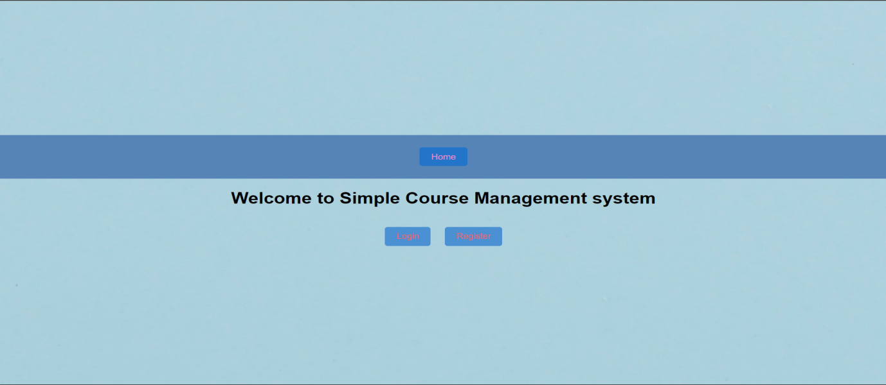

**Login page:**

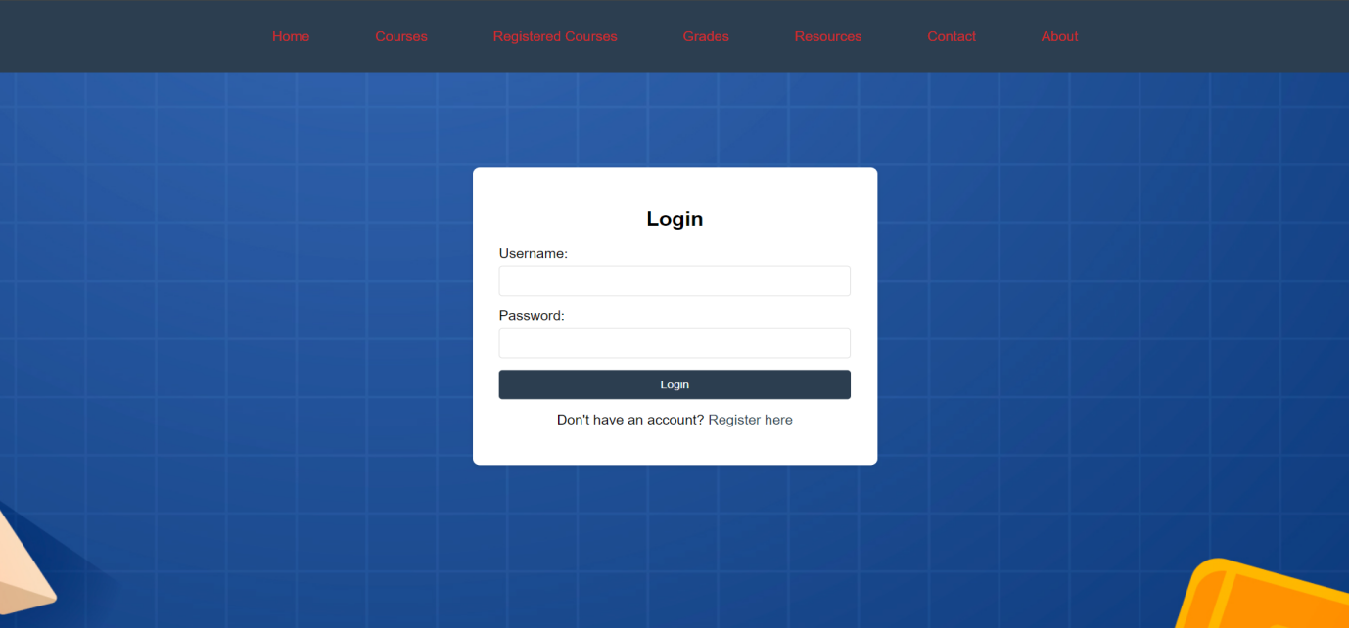

**Registration page:**

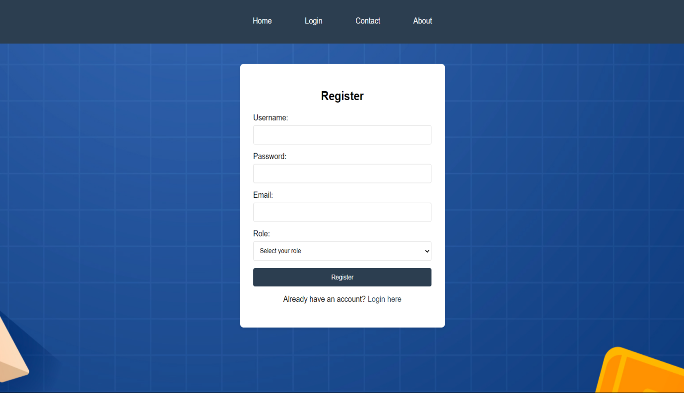

**Home page:**

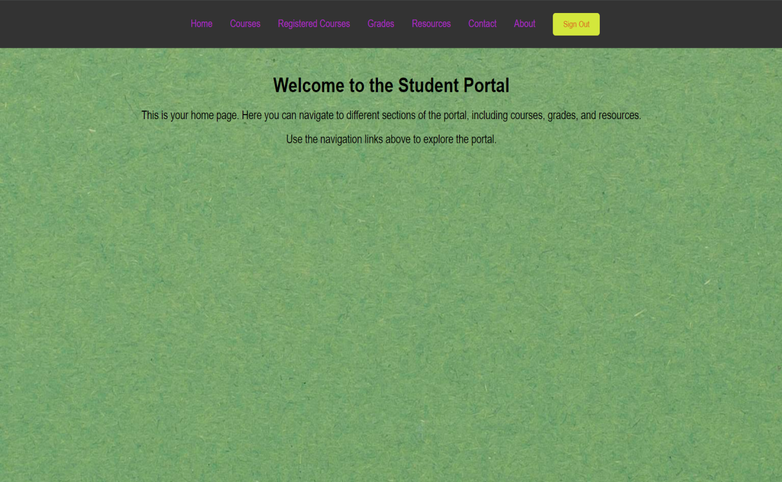

**Courses page:**

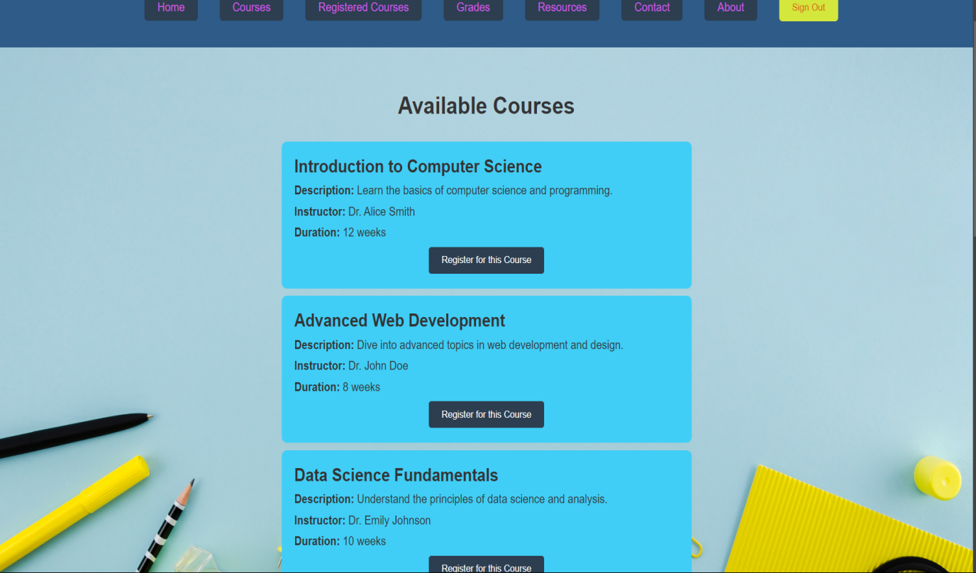

**Registeredcoursepage:**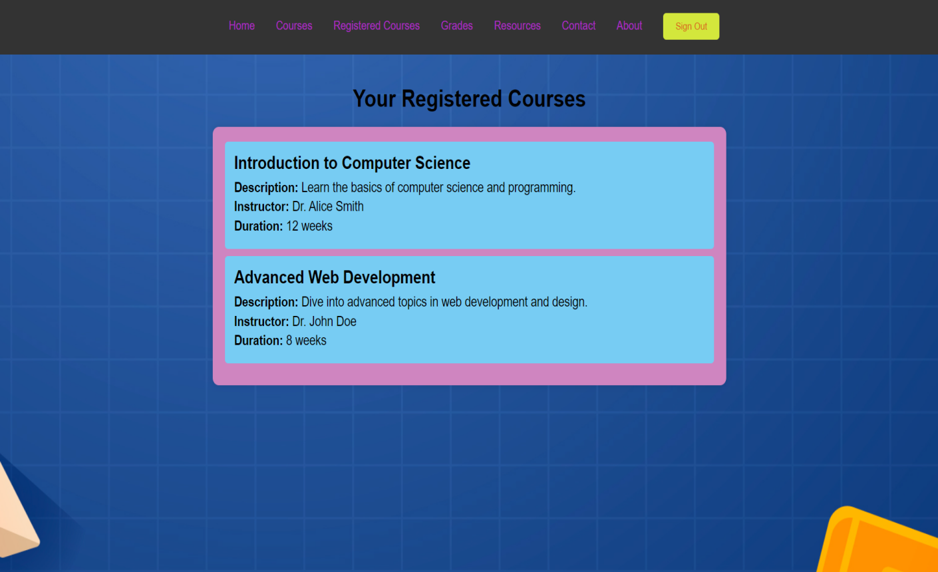

**Grades page:**

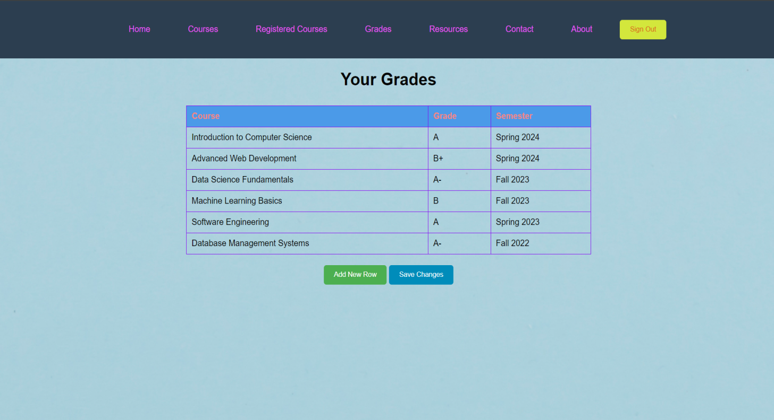

**Resoursepage:**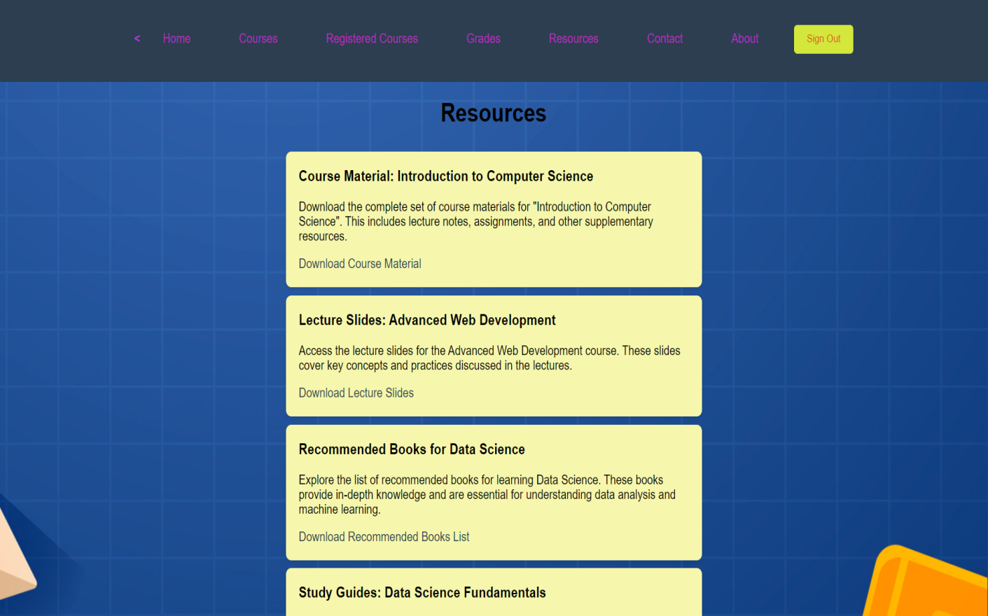

**Contactpage:**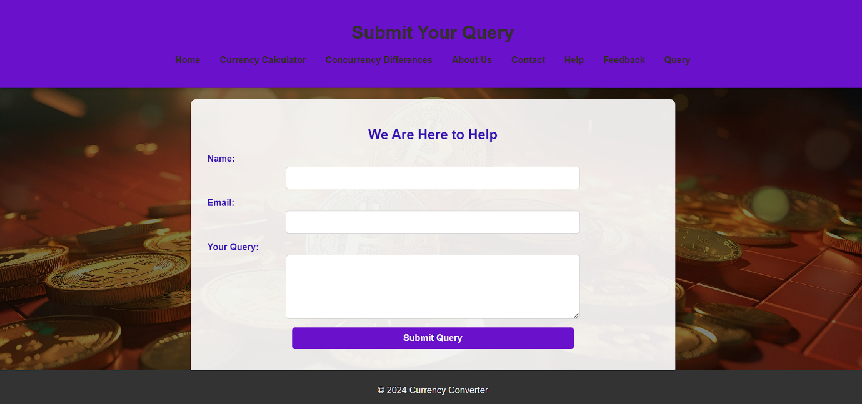

**About page:**

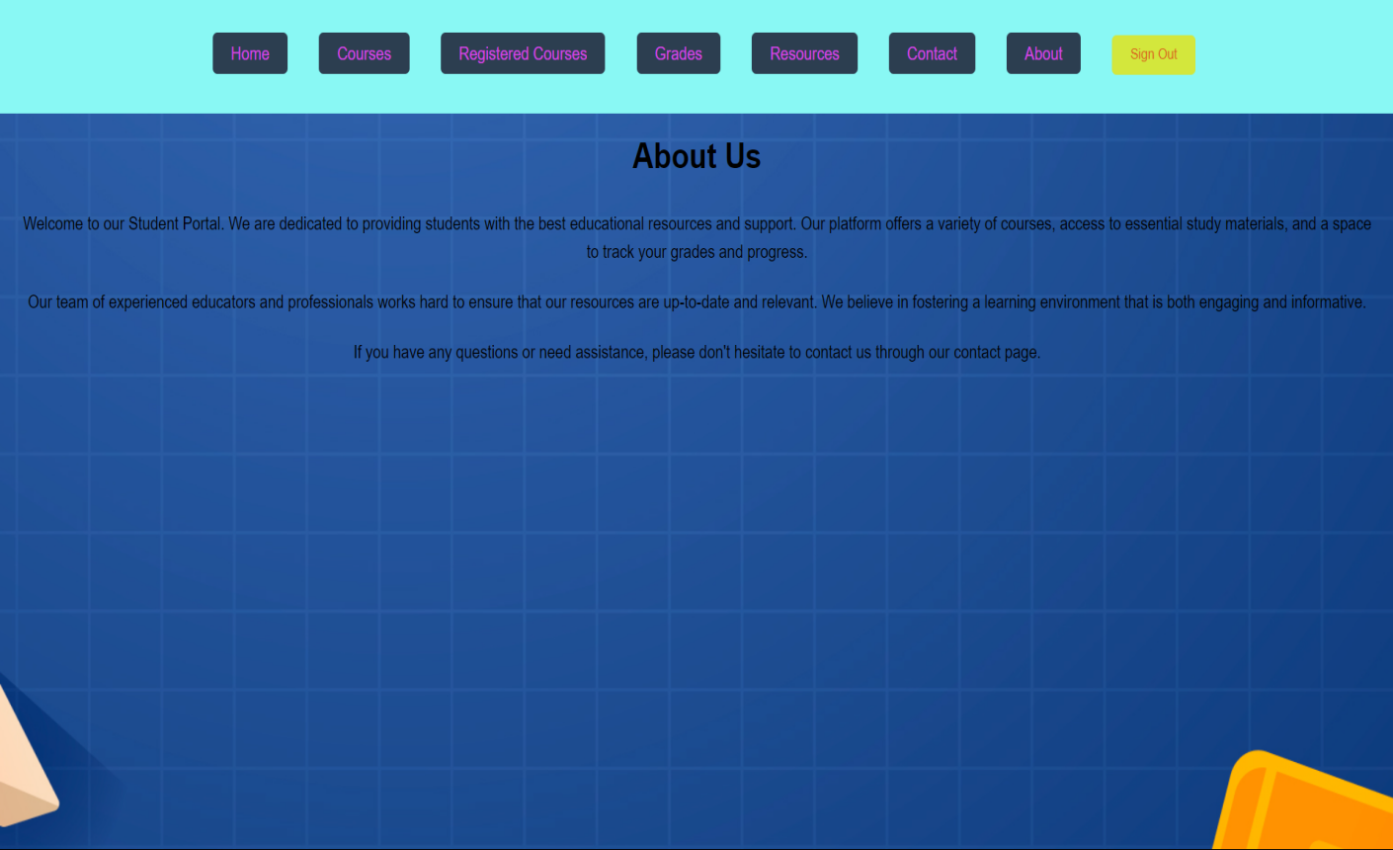

**9.Conclusion :**

The development of the Course Management System marks a significant step forward in streamlining and improving the educational process. By providing a centralized platform for students and educators to manage courses, track grades, and access educational resources, the system fosters a more efficient and user-friendly academic environment. This system addresses common challenges such as manual grade tracking, disparate resources, and inefficient course registration processes by offering a cohesive, digital solution. The incorporation of features such as editable grade tables and real-time updates ensures that the system remains adaptable and responsive to the needs of its users.

**Future Enhancements:**

The Simple Course Management System (SCMS) is designed to provide a foundational platform for managing educational courses efficiently. However, as technology and user needs evolve, there are several potential enhancements that can be implemented to further improve its functionality, user experience, and overall effectiveness.

## References

1. Development of Web-Based Systems
2. User Interface Design
3. Web Technologies
4. Learning Management Systems
5. Data Analytics in Education